SUMMARY STATICS.

County Site Aflatoxin Concentration

Busia :356 Farm store :176 AFB1:178 Min. : 0.0100

Migori:356 NCPB depot :184 AFB2:178 1st Qu.: 0.1375

Retail store  :176 AFG1:178 Median : 1.3200

Wholesale store :176 AFG2:178 Mean : 4.2920

3rd Qu.: 4.8900

Max. :33.8500

ANOVA TEST

**ONE WAY ANOVA TEST.**

This was carried out to help determine if the four main Aflatoxins types aflatoxin B1 (AFB1), aflatoxin B2 (AFB2), aflatoxin G1 (AFG1), and aflatoxin G2 (AFG2 were major influence in the concentrations across the four Sources in the two the regions. This was carried out with A **null hypothesis H0 That** There was no difference means on the concentrations attributed to AFLATOXIN TYPE tested.

RESULTS.

Df Sum Sq Mean Sq F value Pr(>F)

Aflatoxin 3 3447 1148.9 31.35 <2e-16 ***

Residuals 708 25950 36.7

---

Signif. codes: 0 ‘***’ 0.001 ‘**’ 0.01 ‘*’ 0.05 ‘.’ 0.1 ‘ ’ 1

The P-Value as shown the result table above is very low at (p<0.05). We there rejected the Null Hypothesis and conclude that the aflatoxin types was a major contributor to the concentration in those regions.

**TWO WAY ANOVA TEST.**

I carried out Two-way Anova type by incorporating different types of stores (Sites). This would help us know if the store from where the sample was collected from had a significant impact on the concentration of Aflatoxin tested. This was done with a null **hypothesis H0 That** there was no difference in means of concentrations attributed to AFLATOXIN TYPE tested and Stores.

**RESULT**

Df Sum Sq Mean Sq F value Pr(>F)

Aflatoxin 3 3447 1148.9 38.79 <2e-16 ***

Site 3 5068 1689.4 57.04 <2e-16 ***

Residuals 705 20881 29.6

---

Signif. codes: 0 ‘***’ 0.001 ‘**’ 0.01 ‘*’ 0.05 ‘.’ 0.1 ‘ ’ 1

The store (site) addition to this model improve this model as supported by the Residual Variance from **36.7in One way analysis of Variance to 29.6** in this analysis.

With a p<0.05 we rejected Null Hypothesis that the difference in means was due chances. Its significantly indicate that the type of store highly influence level of Aflatoxin concentration in the samples.

Investigating the interactions between the variables Aflatoxin and Site(Store) that can explain the difference in the means of concentrations.

Df Sum Sq Mean Sq F value Pr(>F)

Aflatoxin 3 3447 1148.9 40.727 < 2e-16 ***

Site 3 5068 1689.4 59.885 < 2e-16 ***

Aflatoxin:Site 9 1246 138.5 4.908 2.12e-06 ***

Residuals 696 19635 28.2

---

Signif. codes: 0 ‘***’ 0.001 ‘**’ 0.01 ‘*’ 0.05 ‘.’ 0.1 ‘ ’ 1

The low sum of square of the interaction between Aflatoxin and Sites and the high p-value suggest that the very little variation in the concentration can be explained by the interaction between the two features/Variables. The chart below was used to check for the homoscedasticity of the Two way Anova model since it was the best-fit model for the data with least AIC score among the three models.

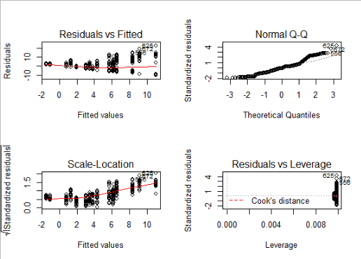

The Q-Q plot has an gradient almost nearing 1, We can therefore says that the model fits the assumption under test.

Post – Hoc Test/

I carried out Tukey Significant Difference (Tukey HSD) tests to help us know the groups which were significantly different from others. The results are as shown below.

**$Aflatoxin**

diff lwr upr p adj

AFB2-AFB1 -4.8869101 -6.372485 -3.4013348 0.000000

AFG1-AFB1 -1.8415730 -3.327148 -0.3559977 0.008019

AFG2-AFB1 -5.3373034 -6.822879 -3.8517280 0.000000

AFG1-AFB2 3.0453371 1.559762 4.5309124 0.000001

**AFG2-AFB2 -0.4503933 -1.935969 1.0351821 0.863203**

AFG2-AFG1 -3.4957303 -4.981306 -2.0101550 0.000000

**$Site**

diff lwr upr p adj

NCPB depot-Farm store -7.184667 -8.6623305 -5.7070025 0.0000000

Retail store -Farm store -2.646932 -4.1409241 -1.1529395 0.0000353

Wholesale store -Farm store -4.841761 -6.3357536 -3.3477691 0.0000000

Retail store -NCPB depot 4.537735 3.0600707 6.0153987 0.0000000

Wholesale store -NCPB depot 2.342905 0.8652411 3.8205691 0.0002887

Wholesale store -Retail store  -2.194830 -3.6888218 -0.7008373 0.0009637

From the results there was a significant difference from mean of concentration of all the types of aflatoxin except between **AFG2-AFB2 with (p>0.05). For the store type there was a significant different in means of concentration for between all the stores types where samples were collected from. This might be due to different storage knowledge amongst the different players in the field.**

**FINAL REPORT.**

We found a statistically-significant difference in average concentration of Aflatoxin tested by both Store type (f(2)=57.04, p < 0.001) and by Aflatoxin type (f(1)=37.79, p<0.001).

A Tukey post-hoc test revealed that fertilizer mix 3 resulted in a higher yield on average than fertilizer mix 1 (0.59 bushels/acre), and a higher yield on average than fertilizer mix 2 (0.42 bushels/acre). Planting density was also significant, with planting density 2 resulting in an higher yield on average of 0.46 bushels/acre over planting density 1.

A subsequent groupwise comparison showed the strongest yield gains at planting density 2, fertilizer mix 3, suggesting that this mix of treatments was most advantageous for crop growth under our experimental conditions.